Gradient Thermal Cycler—MTC9600
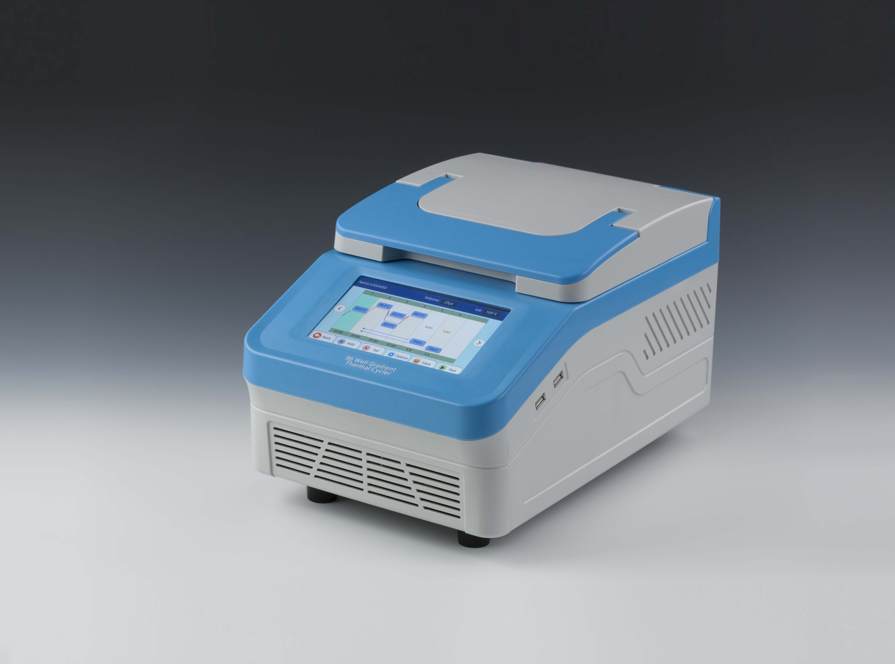

1. Introduction
Gradient Thermal Cycler is a gene amplification instrument with gradient PCR function derived from ordinary PCR instrument. It is produced by basing on highly reliable semiconductor peltier and embedded operating system. Gradient thermal cycler is ideal for thermal cycling and protocol optimization in molecular biology, medical, food, genetic testing and etc.
Features:
- Excellent amplication due to high quality semiconductor peltier.
- Reinforced aluminum block with anodizing technology can keep rapid
heating-conducting property and have enough corrosion resistence.
- The fastest heating and cooling rate of 5°C /s save valuable experimental time.
- 7-inch color touch screen—for easy programming of users.
- Self adjusting heated lid: excellent anti-evaporation effect, it can adapt to different height test tubes.
- Gradient PCR set up with 12 different temperatures.
- Built-in standard procedure document template can quickly edit the required documents.
- One-click quick incubation function can meet the needs of experiments such as denaturation, enzyme cutting/enzyme-link, and ELISA.
- Support U disk to get PCR data to update software.
- Automatic restart after power failure.
- Automatic fault detection and alarm function.

2. Parameters
Capacity | 96x0.2ml (0.2ml PCR tubes, 8-tube strips)
Temp. setting range | 0°C ~105°C
Temp. control range | RT.-25°C ~105°C
Heated lid temp. setting range | 30°C ~112°C
Heated lid temp. control range | RT+5°C ~112°C
Temp. uniformity | ≤±0.2°C
Temp. accuracy | ≤±0.2°C
Max. heating rate | 5°C /sec
Max. cooling rate | 4°C /sec
Temp. display resolution | 0.1°C
Temp. control method | Block/Tube
Display | 7-inch color touch screen, 800x480 Pixel
Communication interface | USBx2
Tm calculation | Automated
Program memory | 10000+
Time increment/decrement | -999~999s
Temp. increment/decrement | -10~10°C
Gradient temp. range | 30~105°C
Gradient setting range | 0.1~30°C
Gradient temp. uniformity | ≤±0.2°C
Gradient temp. accuracy | ≤±0.2°C
Temp. change rate | 0.1~4°C /s
Single step time range | 0~9h59min59s/∞
Program max. cycle numbers | 200
Max. steps of the program | 30
Program pause function | Yes
16°C insulation | Forever
Auto data protection | Yes
On-screen report | Yes
Power | 800W
Voltage | AC100~240V, 50-60Hz
Fuse | 250V 10A Ф5×20
Dimension(mm) | 420x260x245
Weight(kg) | 11

